Statement of Work

Team 3 || Movie Database Final Project ||

Development outline: This project will take information regarding movies from the website IMDB and will store it into a database. Then query the database to show us the required statistics for the movies. 1) Collect information regarding Movies and their categories (Reviews, popularity, Length, budgets) 2) Store all the information using a table 3) Present the Project

Execution: The plan is to use IMDB to fill out our Movie Database, Then to created a table that collects and sorts movies into separate categories (Review’s, Popularity, Length and possibly Budget) The presentation will be on either on December 9 or 10th depending on Justin’s schedule.

# Timeline

* November 18, 2020: Start the SoW
* November 23, 2020: Review and sign SoW
* November 24, 2020: Turn in signed and completed SoW
* November 30, 2020: Meet for Group Project attendance
* December 7, 2020: Meet for Group Project attendance 2
* December 8, 2020: Start gathering all presentation resources
* December 9-10, 2020: Present our Group Project Presentation



* December 10, 2020: Turn in Group Project Source

# Acceptance of Scope of Work



**Team 3**

By signing and dating you agree to the terms above and



Signature: ______________________________

Name: Dylan McCormack

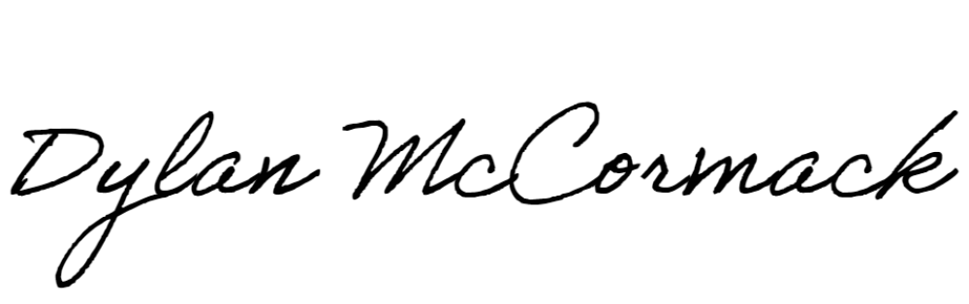

Signature: ______________________________

Name: Eric Yevenko

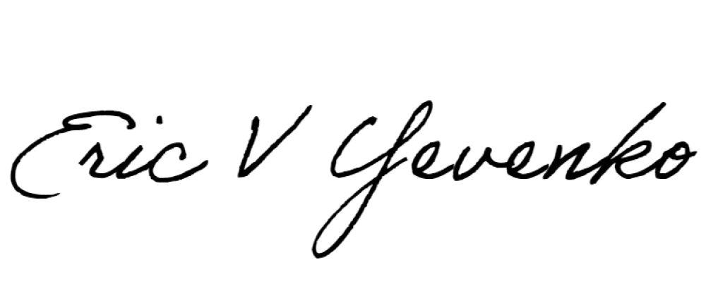

Signature: _________________________

Name: Suhad S AL-Saedi